Oblique Projection
# Source: AI Source: Provided by: [Data Path: Persons Table -> ID Column: 1, Name_En Column: Motasem Essam] -> From: [ChatGPT] on [7/25/2026]
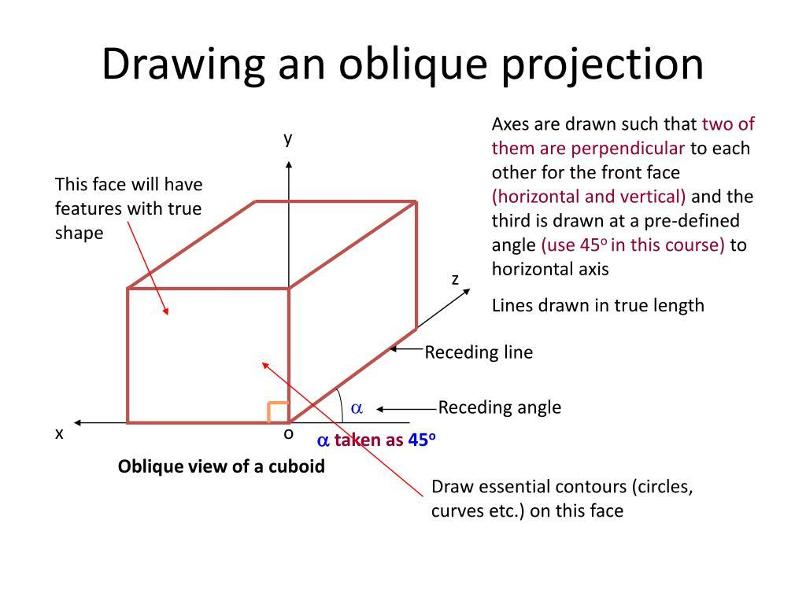
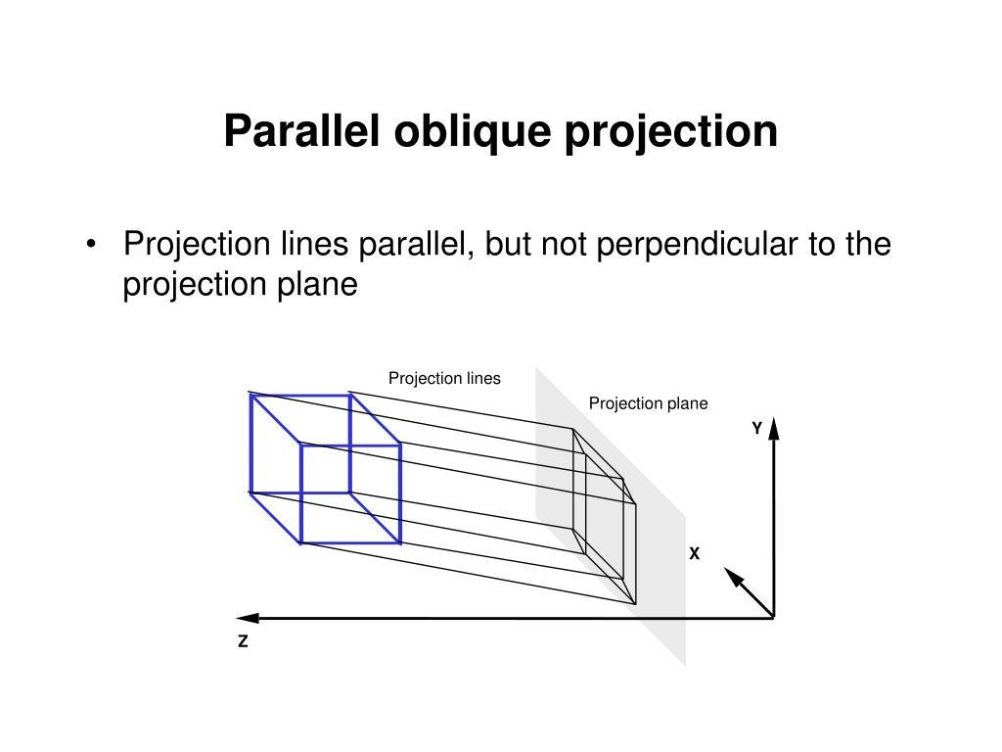
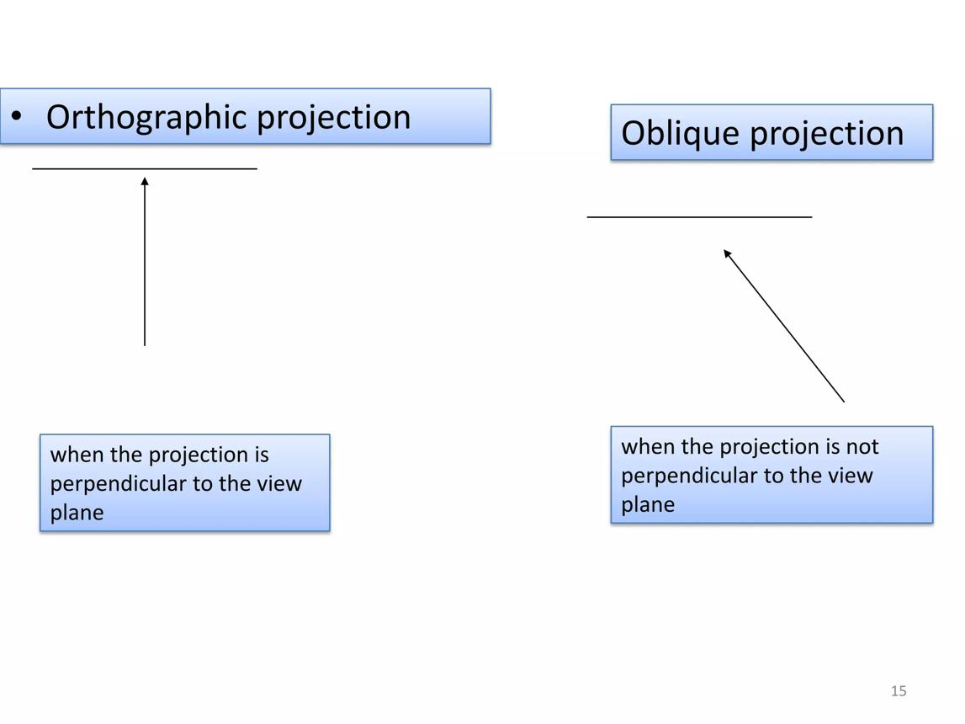

Definition
# Source: AI Source: Provided by: [Data Path: Persons Table -> ID Column: 1, Name_En Column: Motasem Essam] -> From: [ChatGPT] on [7/25/2026]
Oblique projection is a type of geometric projection in which points or objects are projected onto a target line or plane along parallel projection lines that are not perpendicular to the target.
Unlike orthogonal projection, where the projection direction is perpendicular to the target, oblique projection uses an inclined direction.
$$\boxed{\text{Oblique Projection}=\text{Parallel projection along an oblique direction}}$$

Purpose
# Source: AI Source: Provided by: [Data Path: Persons Table -> ID Column: 1, Name_En Column: Motasem Essam] -> From: [ChatGPT] on [7/25/2026]
Oblique projection is used to:
- Represent three-dimensional objects on a two-dimensional surface.
- Show the front face of an object while also showing its depth.
- Create technical and engineering drawings.
- Represent 3D objects using a relatively simple 2D drawing.
- Study parallel projection geometrically.
- Visualize spatial relationships.

Basic Configuration
# Source: AI Source: Provided by: [Data Path: Persons Table -> ID Column: 1, Name_En Column: Motasem Essam] -> From: [ChatGPT] on [7/25/2026]
Suppose a point $P$ is projected onto a plane $Π$.
In oblique projection, the projection line through $P$ is not perpendicular to $Π$.
If $P^{'}$ is the projected point:
$$P→P^{'}$$
and the projection line has direction $d$, then:
$$\boxed{PP^{'}⟂̸Π}$$
The projection lines for different points are normally parallel to one another.

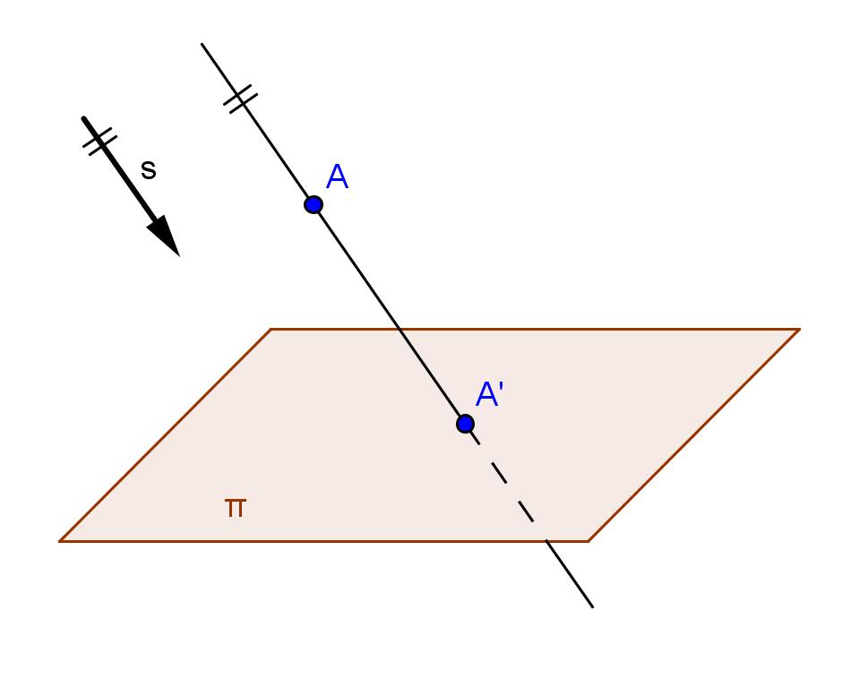
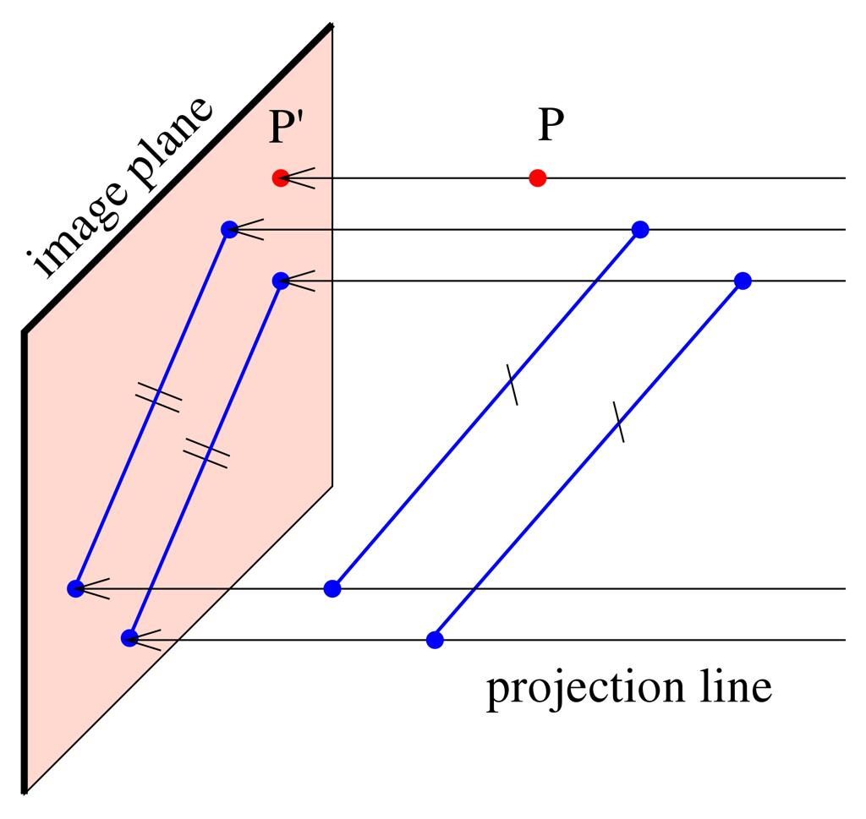
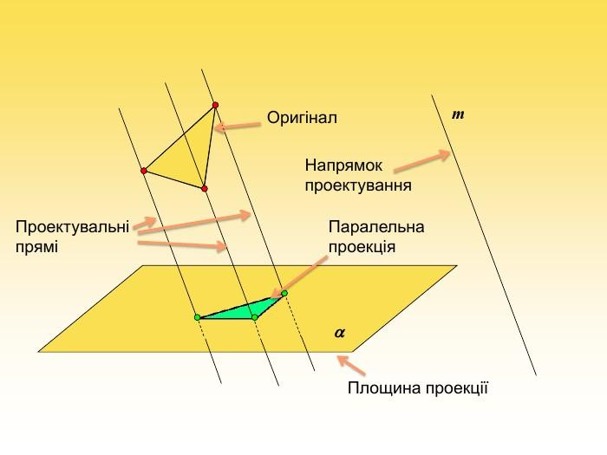

Fundamental Elements
# Source: AI Source: Provided by: [Data Path: Persons Table -> ID Column: 1, Name_En Column: Motasem Essam] -> From: [ChatGPT] on [7/25/2026]
An oblique projection contains three main elements:

1. Original Object
# Source: AI Source: Provided by: [Data Path: Persons Table -> ID Column: 1, Name_En Column: Motasem Essam] -> From: [ChatGPT] on [7/25/2026]
The object being projected.
It can be:
- a point,
- line,
- segment,
- polygon,
- or three-dimensional solid.

2. Projection Direction
# Source: AI Source: Provided by: [Data Path: Persons Table -> ID Column: 1, Name_En Column: Motasem Essam] -> From: [ChatGPT] on [7/25/2026]
The direction along which the projection lines travel.
For oblique projection:
$$\boxed{d⟂̸Π}$$

3. Projection Plane
# Source: AI Source: Provided by: [Data Path: Persons Table -> ID Column: 1, Name_En Column: Motasem Essam] -> From: [ChatGPT] on [7/25/2026]
The plane onto which the object is projected.
The projected object lies on this plane.

Oblique Projection of a Point
# Source: AI Source: Provided by: [Data Path: Persons Table -> ID Column: 1, Name_En Column: Motasem Essam] -> From: [ChatGPT] on [7/25/2026]
Let $P$ be a point outside a plane.
Draw a line through $P$ parallel to the chosen projection direction.
Where this line intersects the projection plane is $P^{'}$.
Therefore:
$$\boxed{P^{'}=\text{oblique projection of }P}$$
The important difference is:
$$PP^{'}⟂̸Π$$

Oblique Projection of a Line Segment
# Source: AI Source: Provided by: [Data Path: Persons Table -> ID Column: 1, Name_En Column: Motasem Essam] -> From: [ChatGPT] on [7/25/2026]
Suppose segment $AB$ is projected onto a plane.
The endpoints become:
$$A→A^{'}$$
and:
$$B→B^{'}$$
Therefore, the projection of the segment is:
$\boxed{A^{'}B^{'}}$
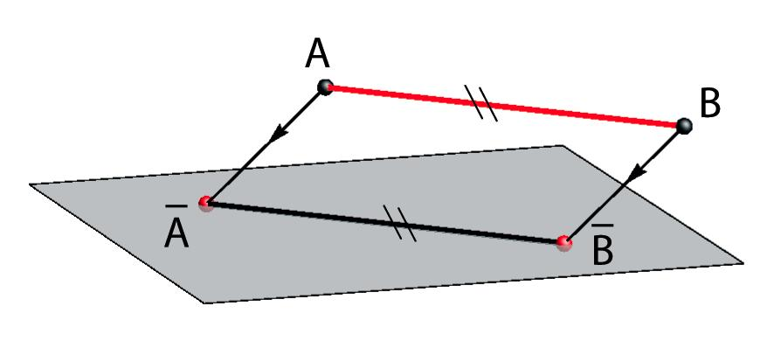
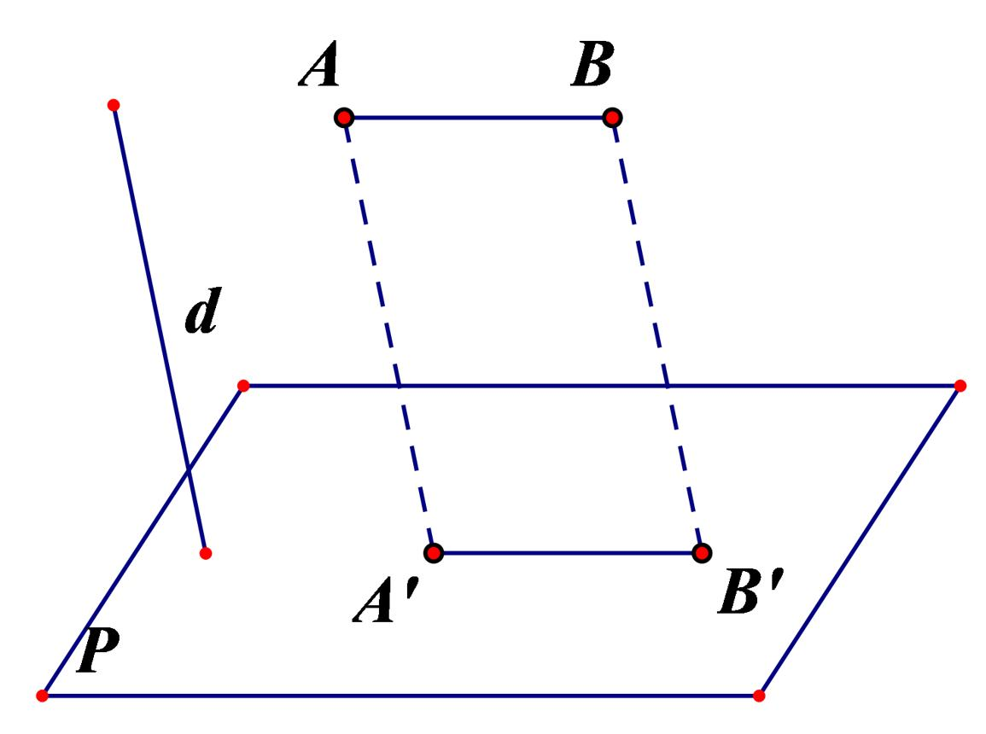
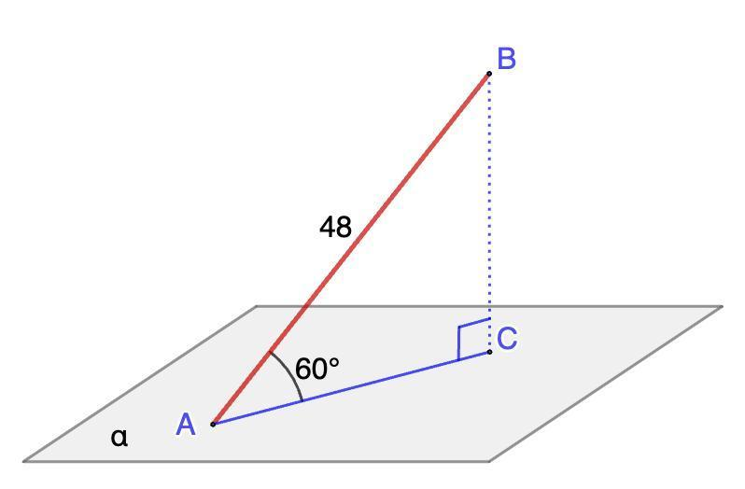
The projection lines:
$$AA^{'}$$
and:
$$BB^{'}$$
are parallel to each other.
However, unlike orthogonal projection:
$$AA^{'}⟂̸Π$$
in general.

Oblique Projection of a 3D Object
# Source: AI Source: Provided by: [Data Path: Persons Table -> ID Column: 1, Name_En Column: Motasem Essam] -> From: [ChatGPT] on [7/25/2026]
Oblique projection is particularly useful for representing 3D objects.
For example, a cube can be represented by drawing:
- The front face.
- Parallel receding lines representing depth.
- The back face connected to the front face.

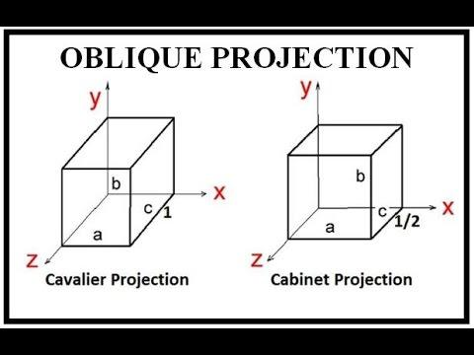
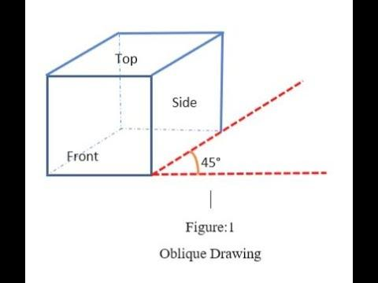
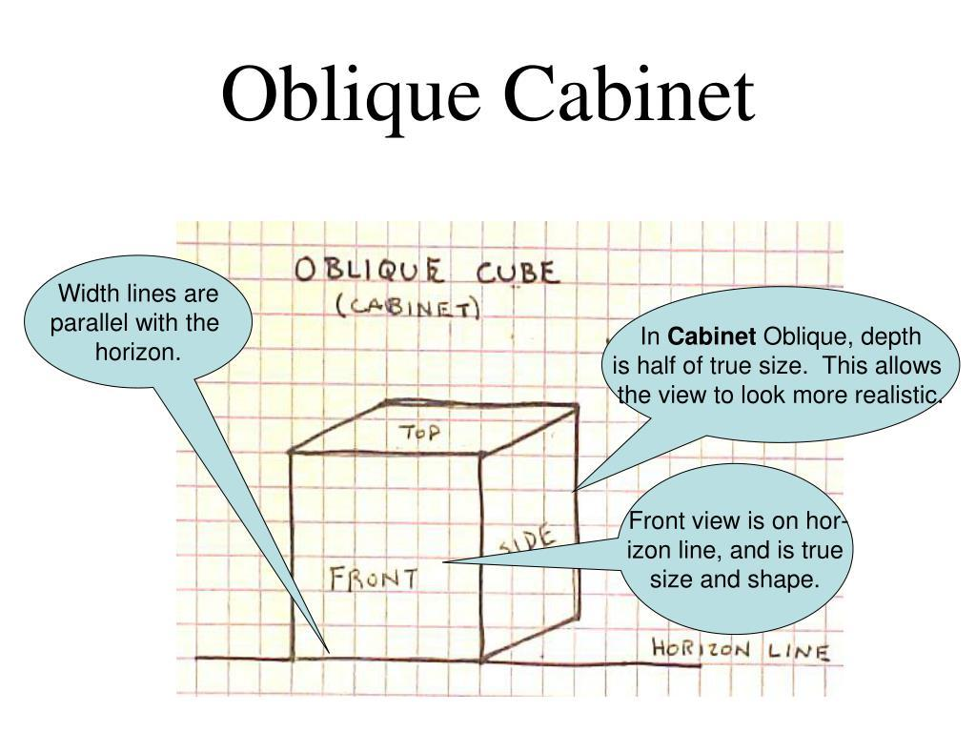
The depth direction is represented by parallel oblique lines.

Mathematical Representation
# Source: AI Source: Provided by: [Data Path: Persons Table -> ID Column: 1, Name_En Column: Motasem Essam] -> From: [ChatGPT] on [7/25/2026]
Let the projection plane be:
$$Π$$
and let the projection direction be:
$$d$$
A point $P$ is projected along the line:
$$P+td$$
for some scalar $t$.
The projected point $P^{'}$ is the value of $t$ for which:
$$P+td∈Π$$
Therefore:
$$\boxed{P^{'}=P+td}$$
where $t$ is determined by the equation of the projection plane.

Oblique Projection onto the $xy$-Plane
# Source: AI Source: Provided by: [Data Path: Persons Table -> ID Column: 1, Name_En Column: Motasem Essam] -> From: [ChatGPT] on [7/25/2026]
Suppose:
$$Π:z=0$$
and the projection direction is:
$$d=(d_{x},d_{y},d_{z})$$
For a point:
$$P=(x,y,z)$$
the projection is:
$$P^{'}=P+td$$
We need:
$$z+td_{z}=0$$
so:
$$t=-\frac{z}{d_{z}}$$
Therefore:
$$\boxed{P^{'}=\left(x-\frac{zd_{x}}{d_{z}},y-\frac{zd_{y}}{d_{z}},0\right)}$$
provided:
$$d_{z}≠0$$
This is a mathematical description of an oblique projection onto the $xy$-plane.

Oblique Projection and Trigonometry
# Source: AI Source: Provided by: [Data Path: Persons Table -> ID Column: 1, Name_En Column: Motasem Essam] -> From: [ChatGPT] on [7/25/2026]
Suppose the projection direction makes an angle $θ$ with the projection plane.
Unlike orthogonal projection, the projection direction is not ${90}^{∘}$ to the plane.
The amount of displacement along the projection direction can be related to trigonometric functions.
For example, if a depth $h$ is represented along a direction making angle $θ$ with the plane, its component within the plane is:
$$\boxed{hcosθ}$$
while its perpendicular component is:
$$\boxed{hsinθ}$$
The exact apparent depth in a drawing also depends on the chosen projection convention.

Types of Oblique Projection
# Source: AI Source: Provided by: [Data Path: Persons Table -> ID Column: 1, Name_En Column: Motasem Essam] -> From: [ChatGPT] on [7/25/2026]
Two important technical drawing forms are:

1. Cavalier Projection
# Source: AI Source: Provided by: [Data Path: Persons Table -> ID Column: 1, Name_En Column: Motasem Essam] -> From: [ChatGPT] on [7/25/2026]
In cavalier projection, the receding/depth dimension is generally represented at its full scale.
If the actual depth is:
$$d$$
then the drawn depth is:
$$\boxed{d_{\text{drawn}}=d}$$
This makes the drawing simple but can make depth appear exaggerated.

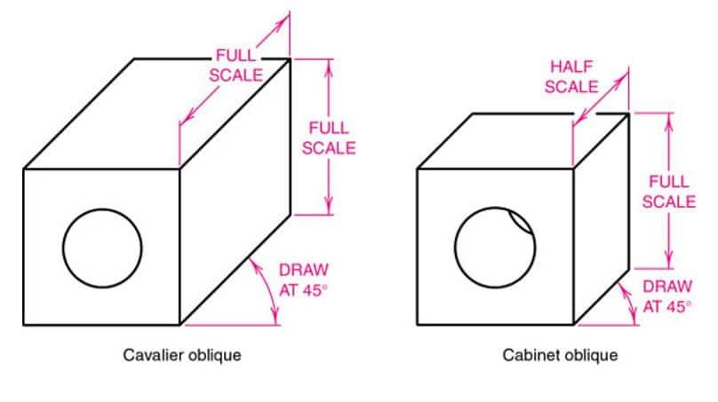
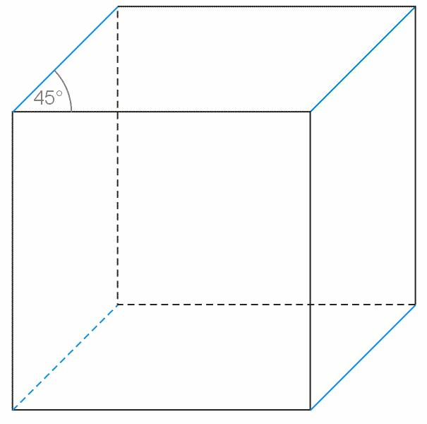
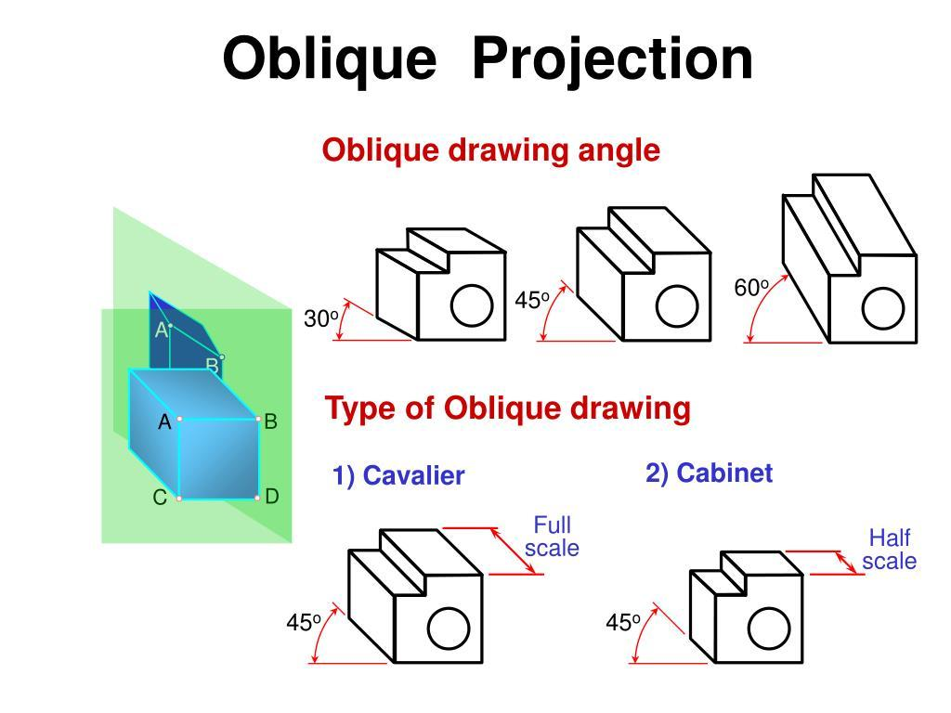

2. Cabinet Projection
# Source: AI Source: Provided by: [Data Path: Persons Table -> ID Column: 1, Name_En Column: Motasem Essam] -> From: [ChatGPT] on [7/25/2026]
In cabinet projection, the receding dimension is commonly reduced, often to half scale.
$$\boxed{d_{\text{drawn}}=\frac{d}{2}}$$
This usually produces a more visually natural representation than full-depth cavalier projection.

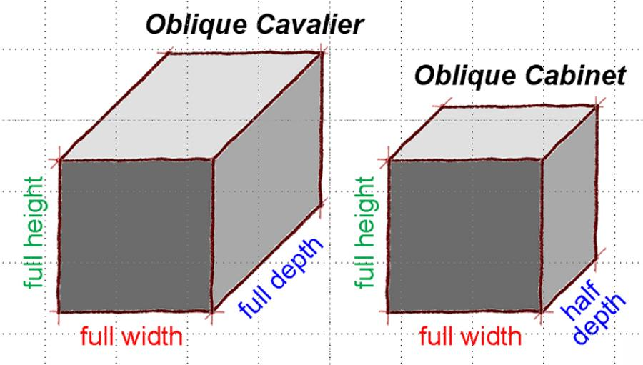
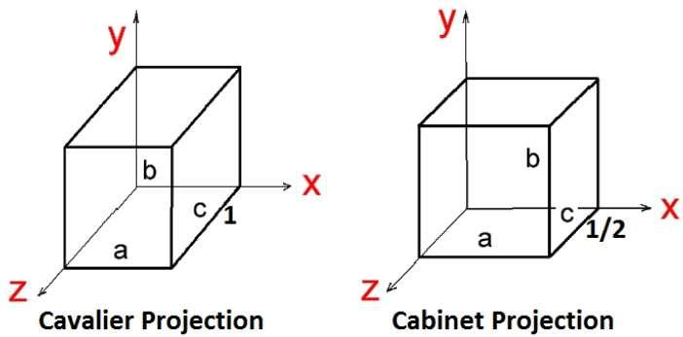
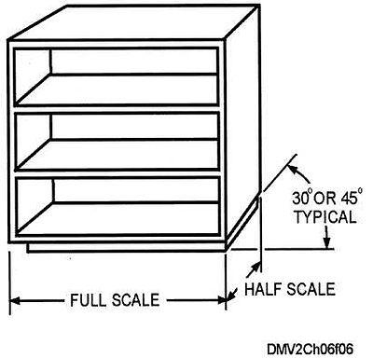

Cavalier vs. Cabinet Projection
# Source: AI Source: Provided by: [Data Path: Persons Table -> ID Column: 1, Name_En Column: Motasem Essam] -> From: [ChatGPT] on [7/25/2026]
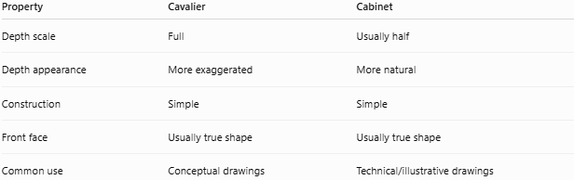
Property | Cavalier | Cabinet
Depth scale | Full | Usually half
Depth appearance | More exaggerated | More natural
Construction | Simple | Simple
Front face | Usually true shape | Usually true shape
Common use | Conceptual drawings | Technical/illustrative drawings

Oblique Projection vs. Orthogonal Projection
# Source: AI Source: Provided by: [Data Path: Persons Table -> ID Column: 1, Name_En Column: Motasem Essam] -> From: [ChatGPT] on [7/25/2026]
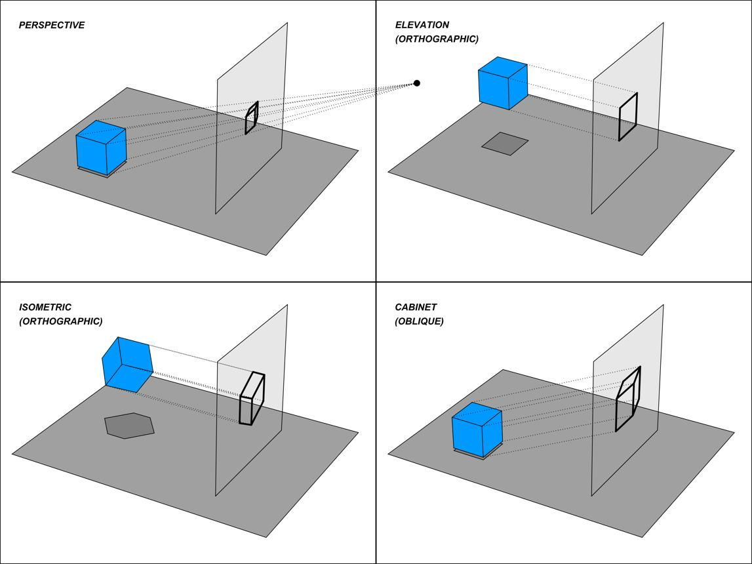
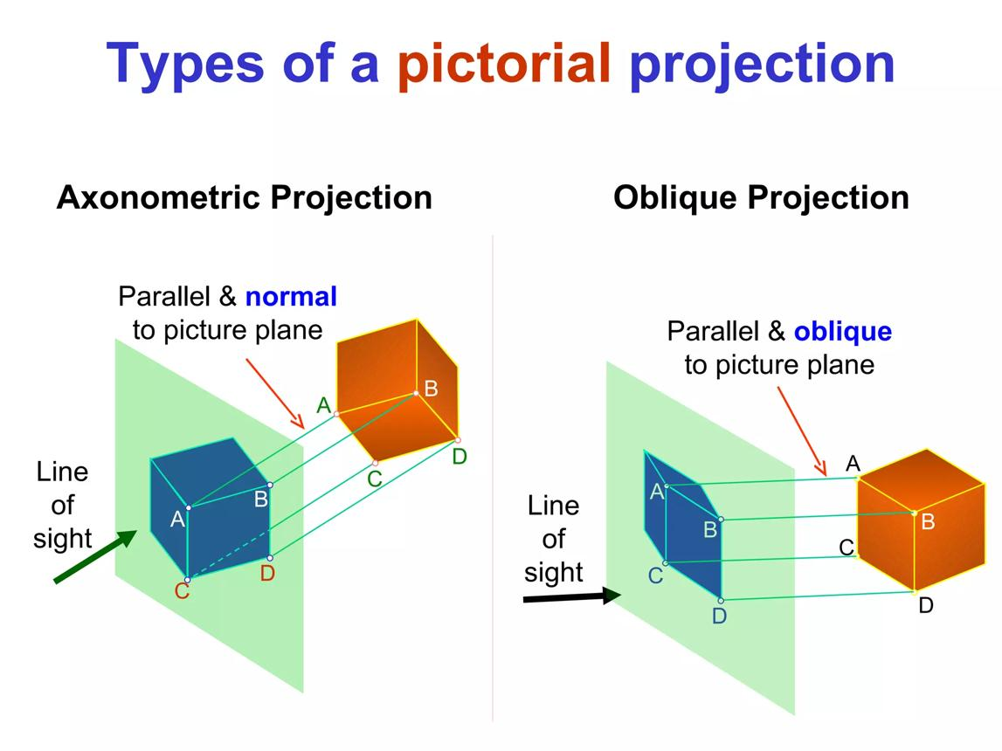
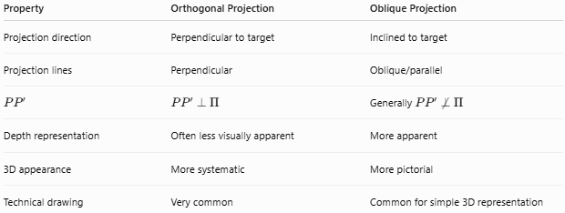
Property | Orthogonal Projection | Oblique Projection
Projection direction | Perpendicular to target | Inclined to target
Projection lines | Perpendicular | Oblique/parallel
$$PP^{'}$$ | $$PP^{'}⟂Π$$ | Generally $PP^{'}⟂̸Π$
Depth representation | Often less visually apparent | More apparent
3D appearance | More systematic | More pictorial
Technical drawing | Very common | Common for simple 3D representation

Oblique Projection vs. Perspective Projection
# Source: AI Source: Provided by: [Data Path: Persons Table -> ID Column: 1, Name_En Column: Motasem Essam] -> From: [ChatGPT] on [7/25/2026]
These are fundamentally different.

Oblique Projection
# Source: AI Source: Provided by: [Data Path: Persons Table -> ID Column: 1, Name_En Column: Motasem Essam] -> From: [ChatGPT] on [7/25/2026]
Projection lines are:
$$\boxed{\text{parallel}}$$
Therefore, parallel edges generally remain parallel.

Perspective Projection
# Source: AI Source: Provided by: [Data Path: Persons Table -> ID Column: 1, Name_En Column: Motasem Essam] -> From: [ChatGPT] on [7/25/2026]
Projection lines converge toward one or more vanishing points.
Therefore, parallel edges in 3D may appear to converge in the image.
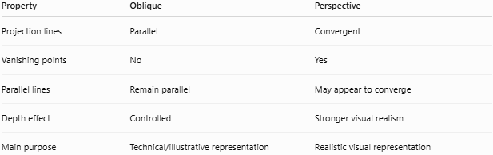
Property | Oblique | Perspective
Projection lines | Parallel | Convergent
Vanishing points | No | Yes
Parallel lines | Remain parallel | May appear to converge
Depth effect | Controlled | Stronger visual realism
Main purpose | Technical/illustrative representation | Realistic visual representation

Important Properties
# Source: AI Source: Provided by: [Data Path: Persons Table -> ID Column: 1, Name_En Column: Motasem Essam] -> From: [ChatGPT] on [7/25/2026]
- Projection lines are generally parallel.
- Projection lines are not perpendicular to the target plane.
- Parallel lines in the object generally remain parallel under an affine oblique projection.
- The projected object lies on the projection plane.
- Lengths are generally not preserved.
- Angles are generally not preserved.
- A line parallel to the projection plane can retain its direction and scale depending on the projection setup.
- Oblique projection is a type of parallel projection.
- It is different from perspective projection because there is no convergence of projection lines.
- Cavalier and cabinet are common forms used for technical visualization.

Special Case — Orthogonal Projection
# Source: AI Source: Provided by: [Data Path: Persons Table -> ID Column: 1, Name_En Column: Motasem Essam] -> From: [ChatGPT] on [7/25/2026]
Oblique projection becomes orthogonal projection when the projection direction becomes perpendicular to the target plane.
Thus:
$$\boxed{d⟂Π}$$
So:
$$\boxed{\text{Orthogonal Projection is a special parallel projection}}$$
but its projection direction is perpendicular to the target.

Applications
# Source: AI Source: Provided by: [Data Path: Persons Table -> ID Column: 1, Name_En Column: Motasem Essam] -> From: [ChatGPT] on [7/25/2026]
Oblique projection is used in:
- Engineering drawings
- Technical illustration
- Architecture
- Mechanical design
- Computer graphics
- Educational diagrams
- 3D visualization
- Product design
- Machine-part drawings

Advantages
# Source: AI Source: Provided by: [Data Path: Persons Table -> ID Column: 1, Name_En Column: Motasem Essam] -> From: [ChatGPT] on [7/25/2026]
- Easy to construct.
- Shows multiple faces of a 3D object.
- Keeps parallel edges parallel.
- Front faces can be represented at their true shape.
- Does not require perspective calculations.
- Useful for technical and educational drawings.

Limitations
# Source: AI Source: Provided by: [Data Path: Persons Table -> ID Column: 1, Name_En Column: Motasem Essam] -> From: [ChatGPT] on [7/25/2026]
- Does not provide realistic perspective.
- Depth can appear distorted.
- Angles are generally not preserved.
- Lengths in the depth direction may be distorted.
- Cavalier projection can make objects appear unnaturally deep.
- The appearance depends strongly on the chosen projection angle and depth scale.

Comparison with Types of Geometric Projection
# Source: AI Source: Provided by: [Data Path: Persons Table -> ID Column: 1, Name_En Column: Motasem Essam] -> From: [ChatGPT] on [7/25/2026]
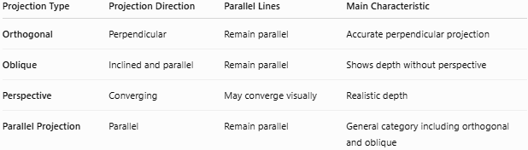
Projection Type | Projection Direction | Parallel Lines | Main Characteristic
Orthogonal | Perpendicular | Remain parallel | Accurate perpendicular projection
Oblique | Inclined and parallel | Remain parallel | Shows depth without perspective
Perspective | Converging | May converge visually | Realistic depth
Parallel Projection | Parallel | Remain parallel | General category including orthogonal and oblique

Key Points
# Source: AI Source: Provided by: [Data Path: Persons Table -> ID Column: 1, Name_En Column: Motasem Essam] -> From: [ChatGPT] on [7/25/2026]
- Oblique projection uses parallel projection lines that are not perpendicular to the target.
- It is a type of parallel projection.
- For a projection plane $Π$:
$$\boxed{d⟂̸Π}$$
- Projection of a point follows:
$$\boxed{P^{'}=P+td}$$
- It is particularly useful for displaying 3D objects on 2D surfaces.
- Cavalier projection generally uses full depth.
- Cabinet projection generally uses reduced depth, commonly half scale.
- Unlike perspective projection, oblique projection does not use converging projection lines.
- Unlike orthogonal projection, the projection direction is inclined rather than perpendicular.

Conclusion
# Source: AI Source: Provided by: [Data Path: Persons Table -> ID Column: 1, Name_En Column: Motasem Essam] -> From: [ChatGPT] on [7/25/2026]
Oblique Projection is a geometric projection method in which an object is projected onto a line or plane along parallel, inclined projection lines.
Its fundamental distinction is:
$$\boxed{\text{Oblique: projection direction is inclined to the target}}$$
while:
$$\boxed{\text{Orthogonal: projection direction is perpendicular to the target}}$$
and:
$$\boxed{\text{Perspective: projection lines converge}}$$
Therefore, the hierarchy can be summarized as:
$$\boxed{\text{Parallel Projection}→\left\{\begin{matrix}\text{Orthogonal Projection} \\ \text{Oblique Projection}\end{matrix}\right.}$$

